**Topic- Elastic Load Balancer (ELB)**

* Step 1- screen shot of the 2 instances.

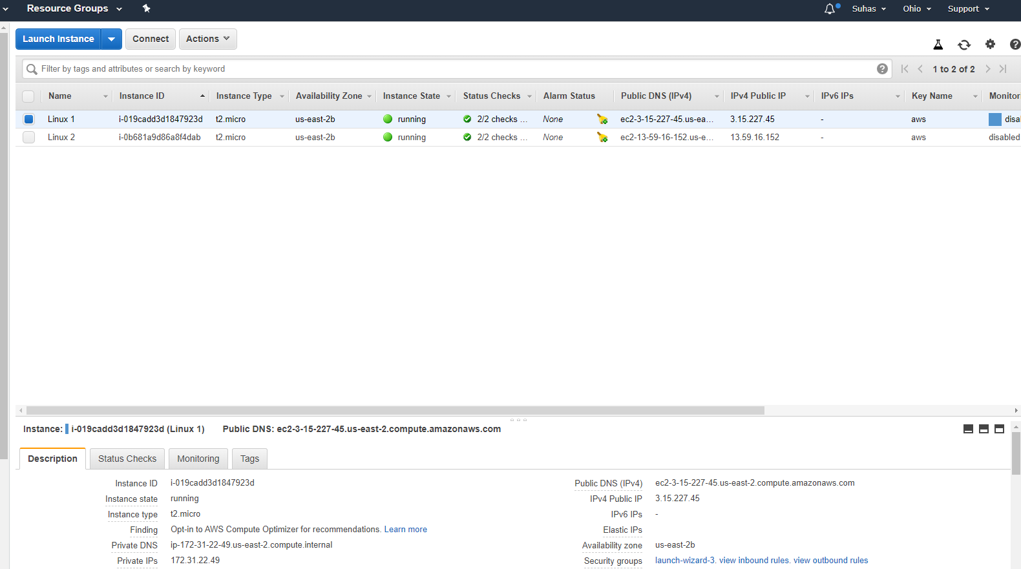

Instance 1 with the IPV4 of 3.15.227.45

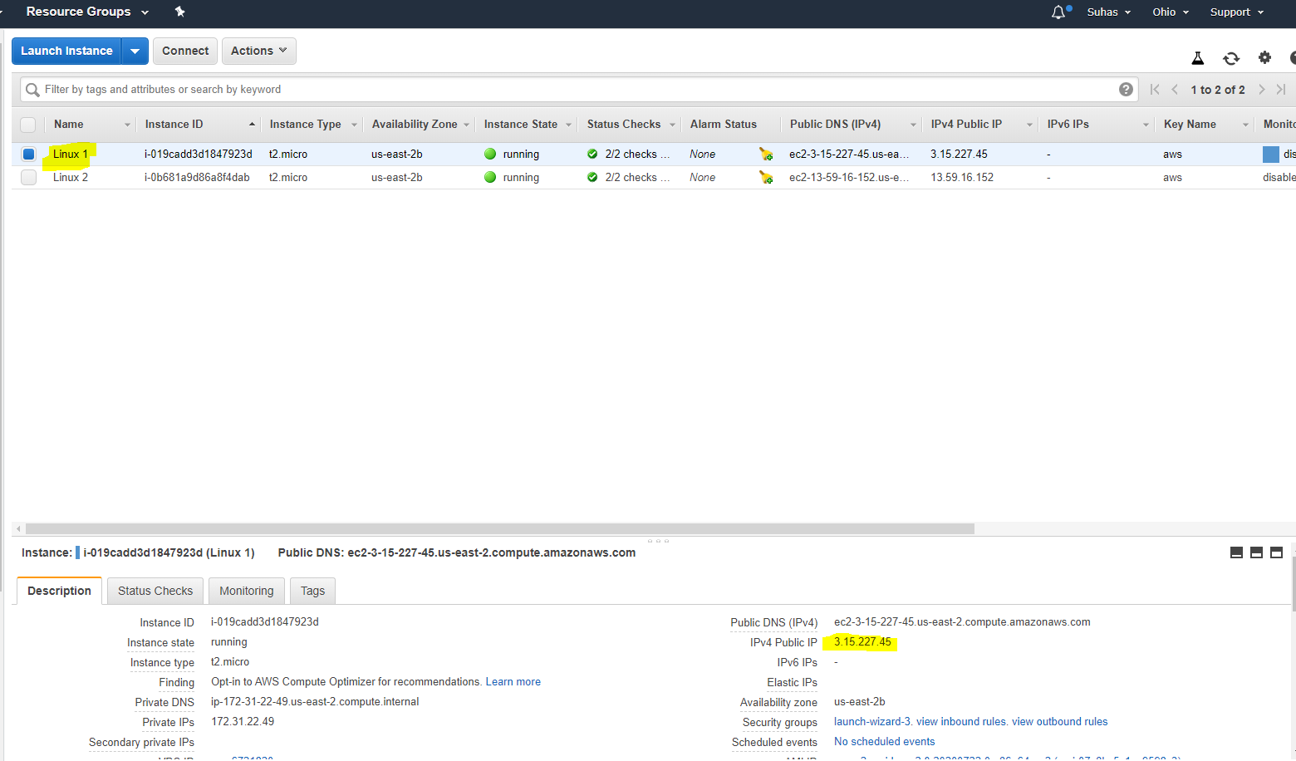

Screen shot of the html link hosted in ipv4 of 3.15.227.45

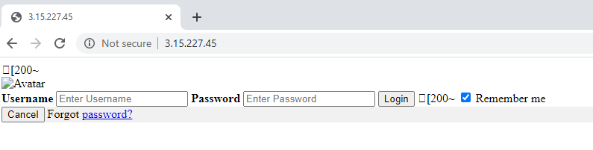

Instance 1 with the IPV4 of 13.59.16.152

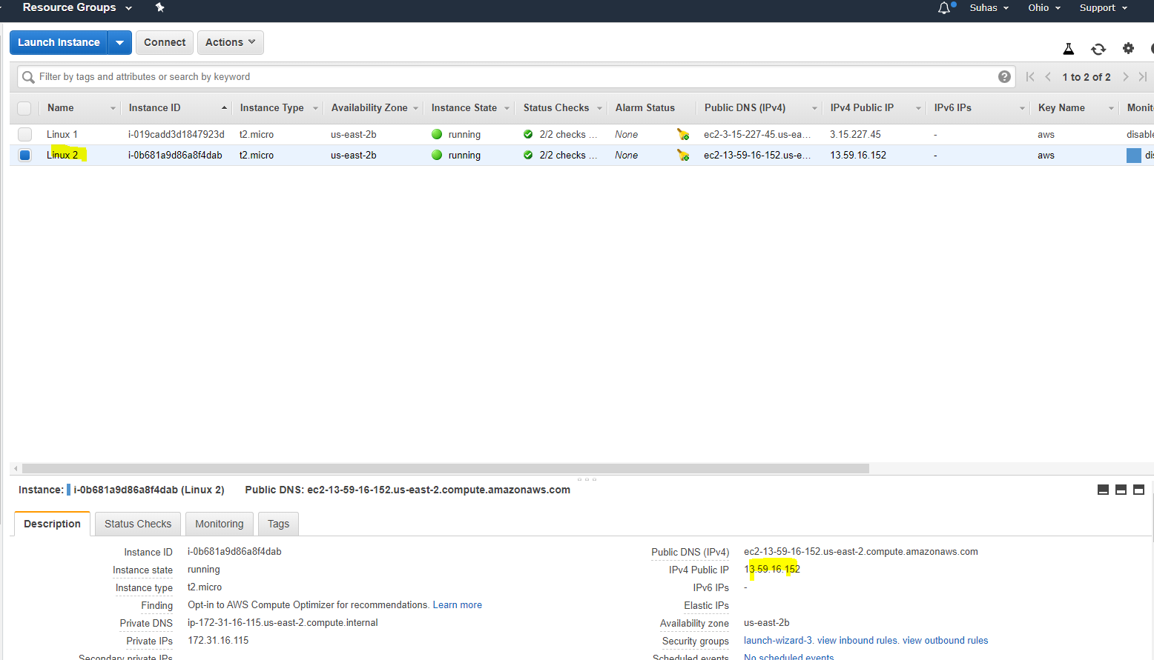Top of Form

Screen shot of the html link hosted in ipv4 of 13.59.16.152.

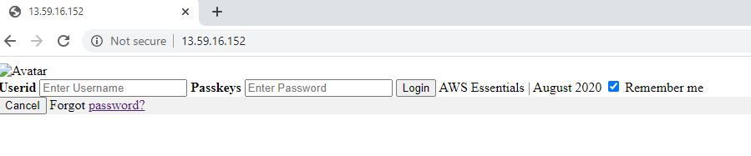

Load balancer created with the name of LetsupgradeELB

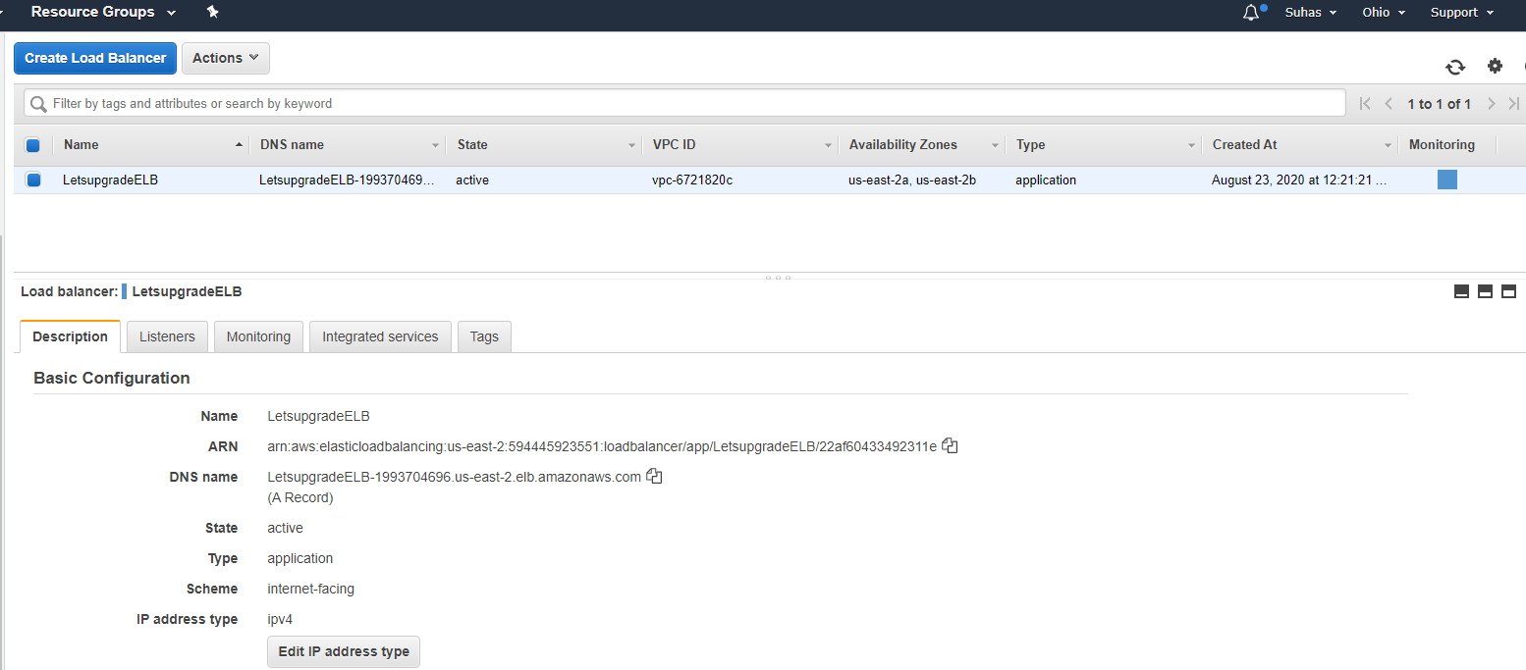

DNS name when hosted.

